HANOI LUXURY CITY FULL-DAY TOUR
Hanoi is the capital of Vietnam and has been a place to keep and witness more than 1000 years of a long history.
That is why this place is a solemn ancient city. Visiting around Hanoi, you will see ancient architectures such as Tran Quoc Pagoda, Ho Chi Minh Complex, One Pillar Pagoda, Vietnam Ethnology Museum or Vietnamese Women’s Museum, Temple of Literature, Hoa Lo Prison. All together create an ancient and historic city.
Coming to Hanoi, you not only see the architectural works but also to immerse yourself in the unique culture here.
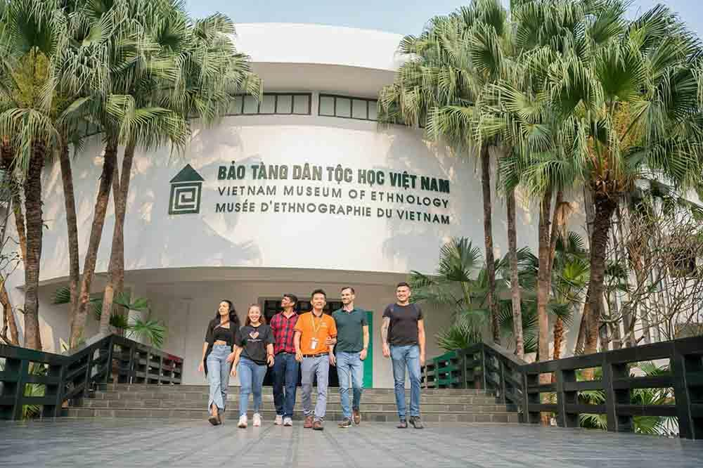
ITINERARY:
7h50 – 8h30: PICK-UP
Our tour guide and driver will pick you up at one of the following nine designated meeting points:
07:50 AM
- 4B Trang Thi Street
- 22 Trang Thi Street
08:00 AM
- 174 Phung Hung Street
- 1 Duong Thanh Street
- 2 Le Van Linh Street
08:10 AM
- 24–26 Tran Nhat Duat Street
- 6 O Quan Chuong Street
- Techcombank Cho Gao street
- 2–4 Nguyen Huu Huan Street
08:20 AM
- 160 Tran Quang Khai Street
- 204 Tran Quang Khai Street
08:30 AM
- Hanoi Opera House

08h45: Visit Ho Chi Minh Complex, the final resting place of Vietnamese great father or Uncle Ho. You have a chance to see the embalmed body of Ho Chi Minh then walk around the garden to see 2 houses where he lived & worked from 1954 to 1969.
Then visit One Pillar Pagoda where worships the Goddess of Mercy – It is the most unique pagoda in the world.
- Should dress modestly by covering from shoulders to knees when visiting Ho Chi Minh Mausoleum, temples, pagodas, etc.
- Ho Chi Minh’s Mausoleum is closed on Mondays and Fridays. But still can take picture of the Mausoleum and visit around that area.
- Ho Chi Minh’s Mausoleum is closed at least 2 months (15th June -15th August) for the annual maintaining.
10h15: Visit Vietnam Ethnology Museum to learn about the culture of 54 ethnic groups living in the whole country of Vietnam.
Special Note: We will visit Vietnamese Women’s Museum instead of Vietnam Ethnology Museum closed on Mondays.
12h30-12h45: Have lunch at our restaurant. You have an opportunity to enjoy Vietnamese cuisine. Vegeterian foods are available.

13h30: Visit Tran Quoc Pagoda located on Golden Fish Island in West Lake. It is the oldest pagoda in Hanoi built in the 6th century.
14h30: Continue to visit Temple of Literature – the first university of Vietnam, The Temple of Literature (Van Mieu Quoc Tu Giam) is one of the most attractive tourist spots in Northern Vietnam. The Temple of Literature was founded in 1070.
15h30: Keep going to visit Hoa Lo Prison, the prison was built by the French, from 1886 to 1901, when Vietnam was still a part of French Indochina. The French called the prison Maison Centrale. The prison was called “A Hell on Earth” and now the prison is like a war museum for those who want to understand more about the war against France of Vietnamese people.
16h30: Our Bus take you back to the Hotel. We finish the trip!
Optional: Cyclo or/and Water Puppet Show can be arranged upon your request with additional fee.
Option 1: Cyclo 45 minutes (5usd/person) around Hanoi Old Quarter after visiting Hoa Lo Prison
Option 2: Water Puppet Show 50 minutes (5usd/person) .
- Recomended time: 16h10 or 17h20
Option 3: Cyclo 45 minutes and Water Puppet Show 50 minutes (10usd/person).
- Recommended time for Water Puppet Show 17h20 or 18h30

INCLUSION
- Shuttle Bus/Limousine during the trip
- A bottle of water/person
- Entrance tickets
- English speaking guide
- Vietnamese Lunch
EXCLUSION
- Drink for lunch
- Cyclo (USD 5/person)
- Water Puppet Show (USD 5/person)
- Tips for tour guide & driver
- Personal expenses or anything not mentioned above
SPECIAL NOTES
- Ho Chi Minh’s Mausoleum is closed on Monday and Friday. But still can take picture of the Mausoleum and visit around that area.
- We will visit Vietnamese Women’s Museum instead of Vietnam Ethnology Museum closed on Mondays.
- Should dress modestly by covering from shoulders to knees in the public places like temples, pagodas, HCM Mausoleum, etc
- Should bring the necessary things such as: cash, cellphone or cameras, raincoat/ umbrella, sun block, etc (depending on the weather).
- The order of the itinerary can be changed depending on the situation.

